11_Feb_2026@AnkitaSadatpure (Week2) Process & Logs

Install node -v
Install npm -v

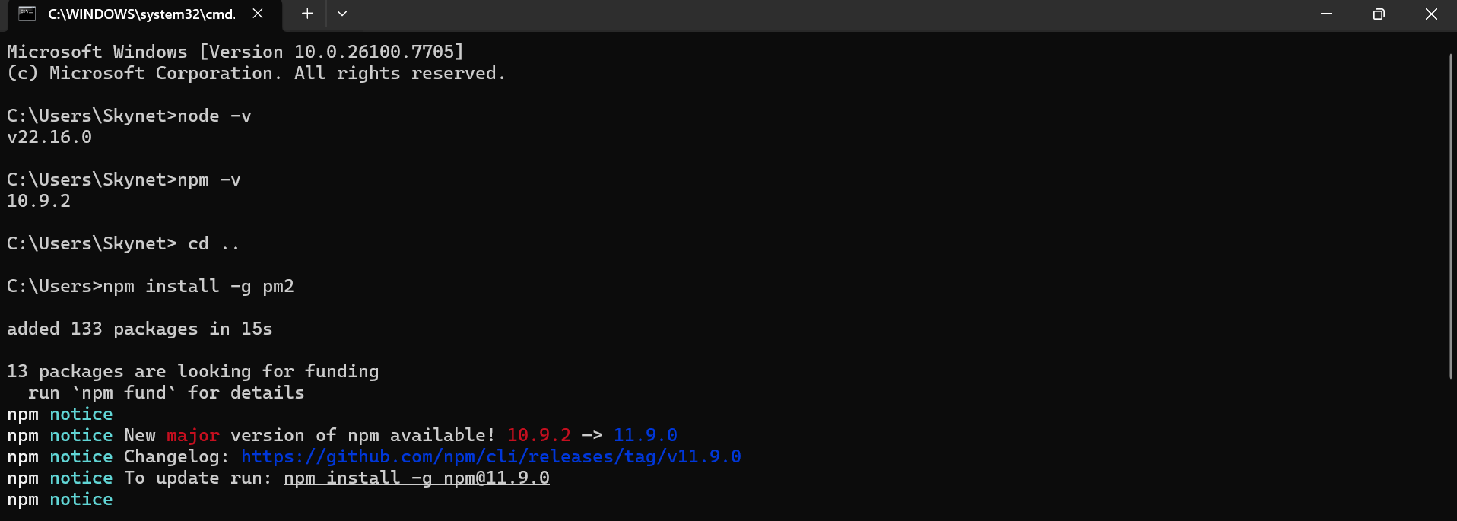

Intsall pm2 npm install -g pm2
Check version pm2 -v

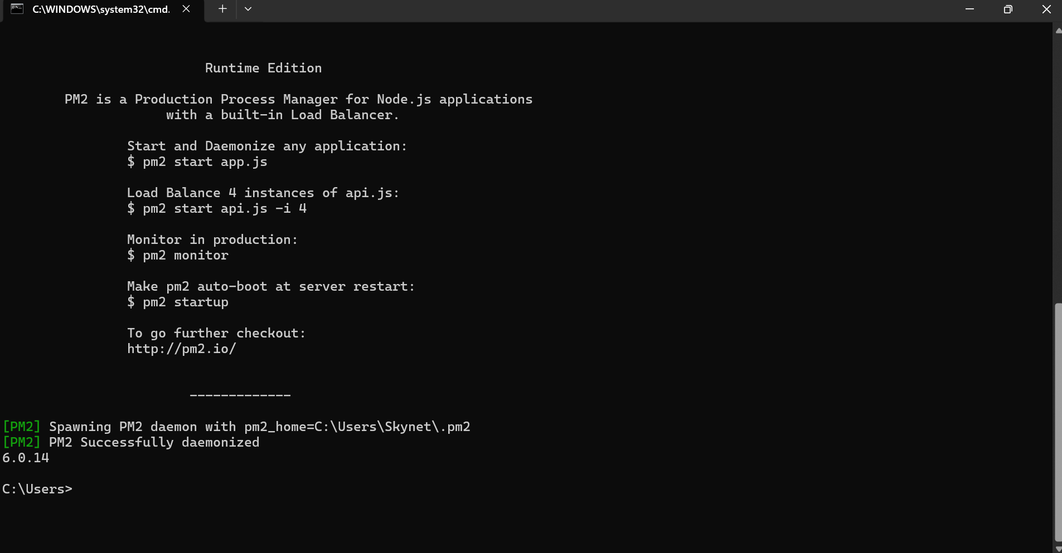

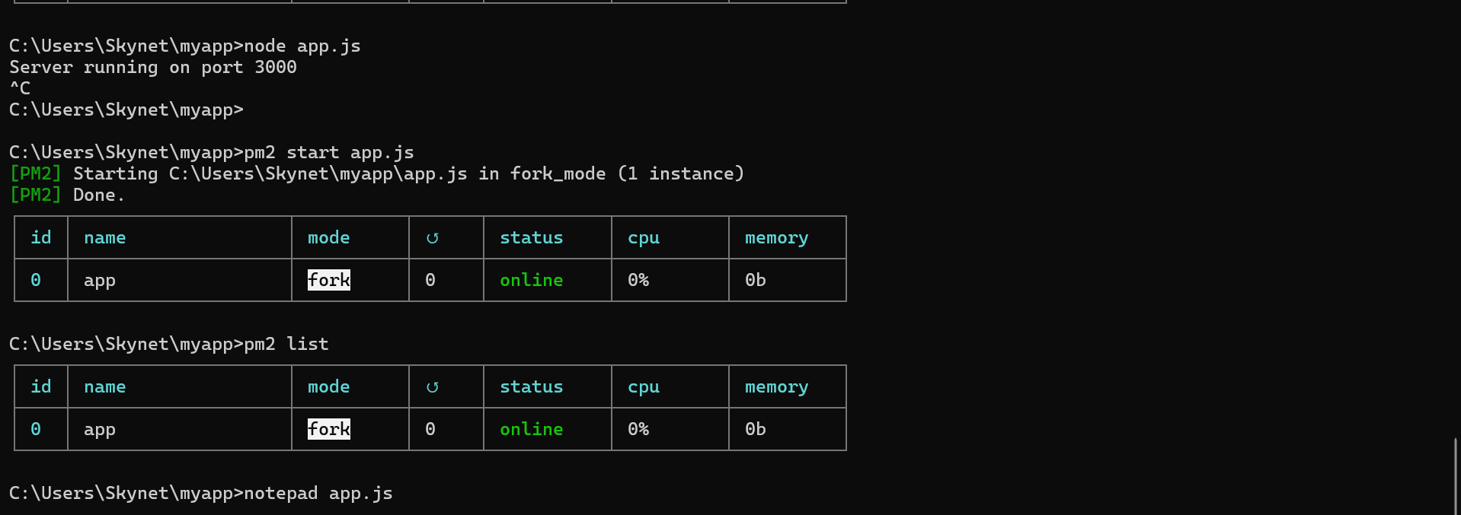

Create Folder
mkdir myappcd myapp
Now you should see:
C:\Users\myapp>

Create app.js
notepad app.js
Paste this to this file:
const http = require('http');
const server = http.createServer((req, res) => {
res.writeHead(200, {'Content-Type': 'text/plain'});
res.end('Node App Running with PM2!');
});

server.listen(3000, () => {
console.log('Server running on port 3000');
});
Save and close.

Run App with PM2
pm2 start app.js
Then check:
pm2 list

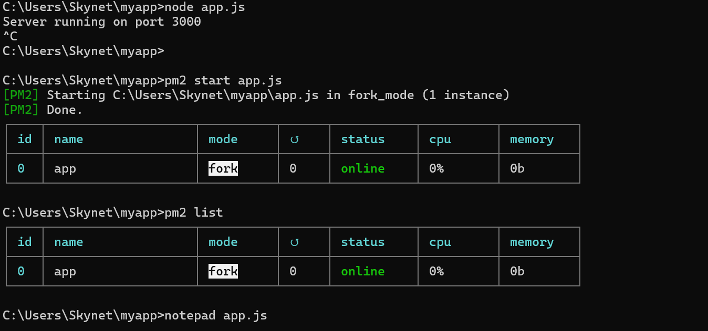

Test
Open browser:
http://localhost:3000
You should see:
Node App Running with PM2!

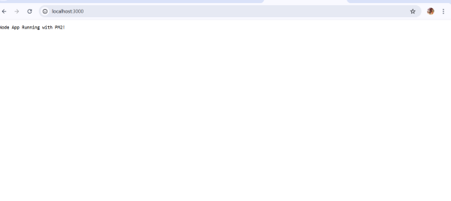

Commands
Stop app:
pm2 stop app
Restart:
pm2 restart app
Delete:
pm2 delete app
See logs:
pm2 logs

To check server
C:\Users\Skynet\myapp>node app.js
Server running on port 3000

Create Project Folder
Go to your folder:
cd C:\Users\Skynet mkdir dummy-website
cd dummy-website

Initialize Node Project
npm init -y
This creates package.json.

Install Express
We’ll use Express (real website setup).
npm install express

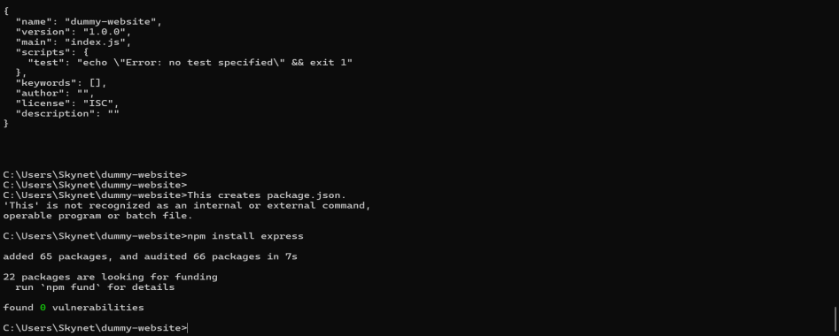

Create server.js
notepad server.js
Paste this:
const express = require('express');const path = require('path');
const app = express();const PORT = 3000;
// Serve static files
app.use(express.static(path.join(__dirname, 'public')));
// Home route
app.get('/', (req, res) => {
res.sendFile(path.join(__dirname, 'public', 'index.html'));
});

app.listen(PORT, () => {
console.log(`Dummy website running at http://localhost:${PORT}`);
});
Save as:
File name: server.js
Save as type: All Files

Create Public Folder
mkdir public
cd public

Test Manually First
node server.js
Open browser:
http://localhost:3000
You should see the dummy website.
If working → press:
Ctrl + C

Run With PM2
pm2 start server.js --name dummy-site
pm2 list
Now open browser again:
http://localhost:3000

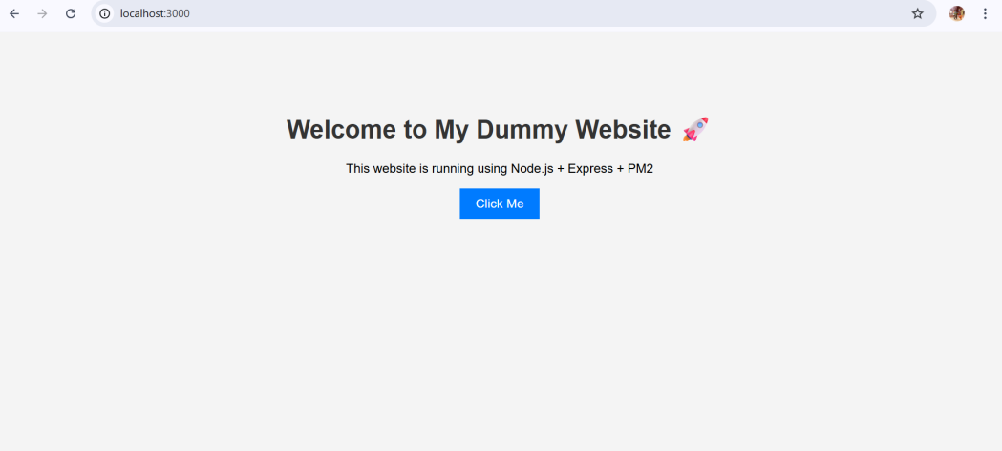

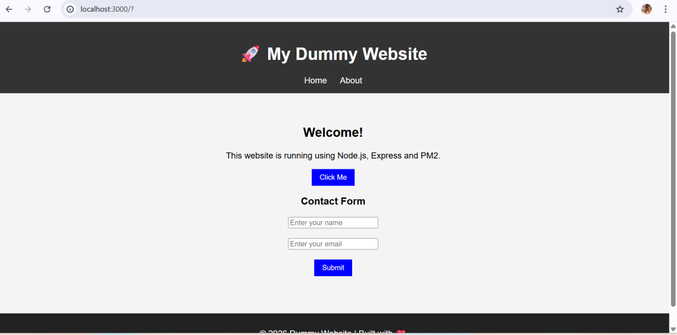

Lunch Ec2 Instace

